VA Nebraska-Western Iowa Health Care System

* + [A to Z List of Services](http://www.nebraska.va.gov/services/index.asp)
  + [Caregivers](http://www.nebraska.va.gov/services/caregiver/index.asp)
  + [Homeless Veterans](http://www.nebraska.va.gov/services/homeless/index.asp)
  + [Returning Service Members](http://www.nebraska.va.gov/services/returning/index.asp)
  + [Women Veterans](http://www.nebraska.va.gov/services/women/index.asp)
* [Health Care Providers](http://www.nebraska.va.gov/providerinfo/index.asp)

Norfolk

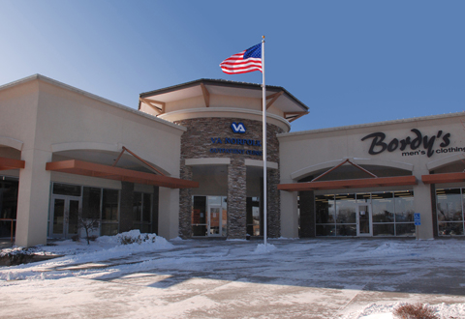

Location

710 S 13th, Suite 1200  
Norfolk, NE 68701

Phone & Fax

**Phone:** 402-370-4570  
**Fax:** 402-370-4582

Hours of Operation

**Clinic Hours:**  8 a.m. to 4:30 p.m. Monday through Friday

**Features**

* Primary care services for veterans in the Norfolk area
* Mental Health services.
* Handicapped Accessible: full and easy access for all veterans.
* Personal Care: Highly qualified primary care providers, most specialty care referrals to the facility in Omaha.
* Laboratory: Blood drawing services available.
* Prescriptions: Routine prescriptions processed through the mail or My HealtheVet.

Page Content

|  |  |  |  |  |  |  |  |  |  |
| --- | --- | --- | --- | --- | --- | --- | --- | --- | --- |
|  | |  |  |  |  |  |  |  |  | | --- | --- | --- | --- | --- | --- | --- | --- | | **Veterans' Homes  Norfolk Veterans' Home**   |  |  | | --- | --- | | Norfolk.jpg (8022 bytes)  **Norfolk Veterans' Home**  600 East Benjamin Avenue Norfolk, NE 68701 |  | | The Norfolk Veterans' Home opened in 1963. Members moved to the current location in 2001. The total capacity is 151, including:   * 30 DOM Unit beds * 30 Special Needs beds * 10 Advance Palliative Care beds * 81 Skilled Nursing Bed  |  |  | | --- | --- | | ​**For general inquiries, call:** 402-370-3330 | ​**Volunteer Services Coordinator** 600 East Benjamin Avenue Norfolk, NE 68701 Phone: (402) 370-3102; Fax: (402) 370-3190 | | | |  | |

**Madison County Veteran Service**

**Gregg Hanson, Veterans’ Services Officer**  
Veteran’s Service Office  
130 South 4th Street  
Norfolk, Nebraska 68748  
Telephone 402-370-3578